ADSD HW6 ORM ToDo(PeeWee)

Local Model page:

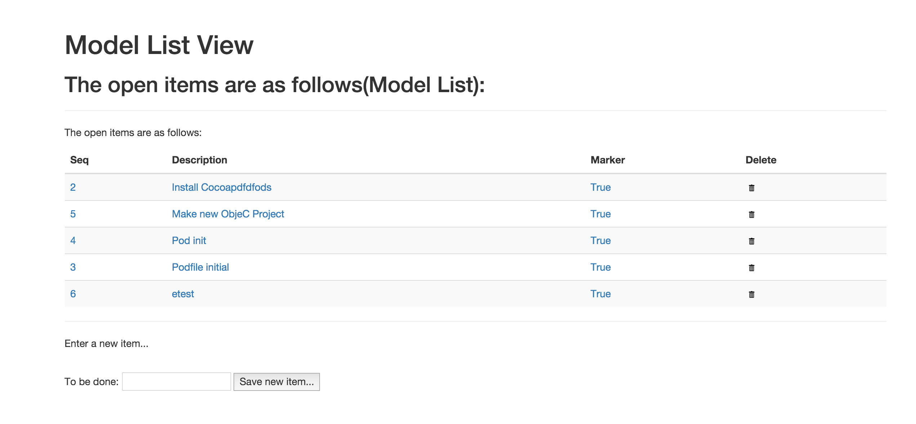

PythonAnywhere Model Page:

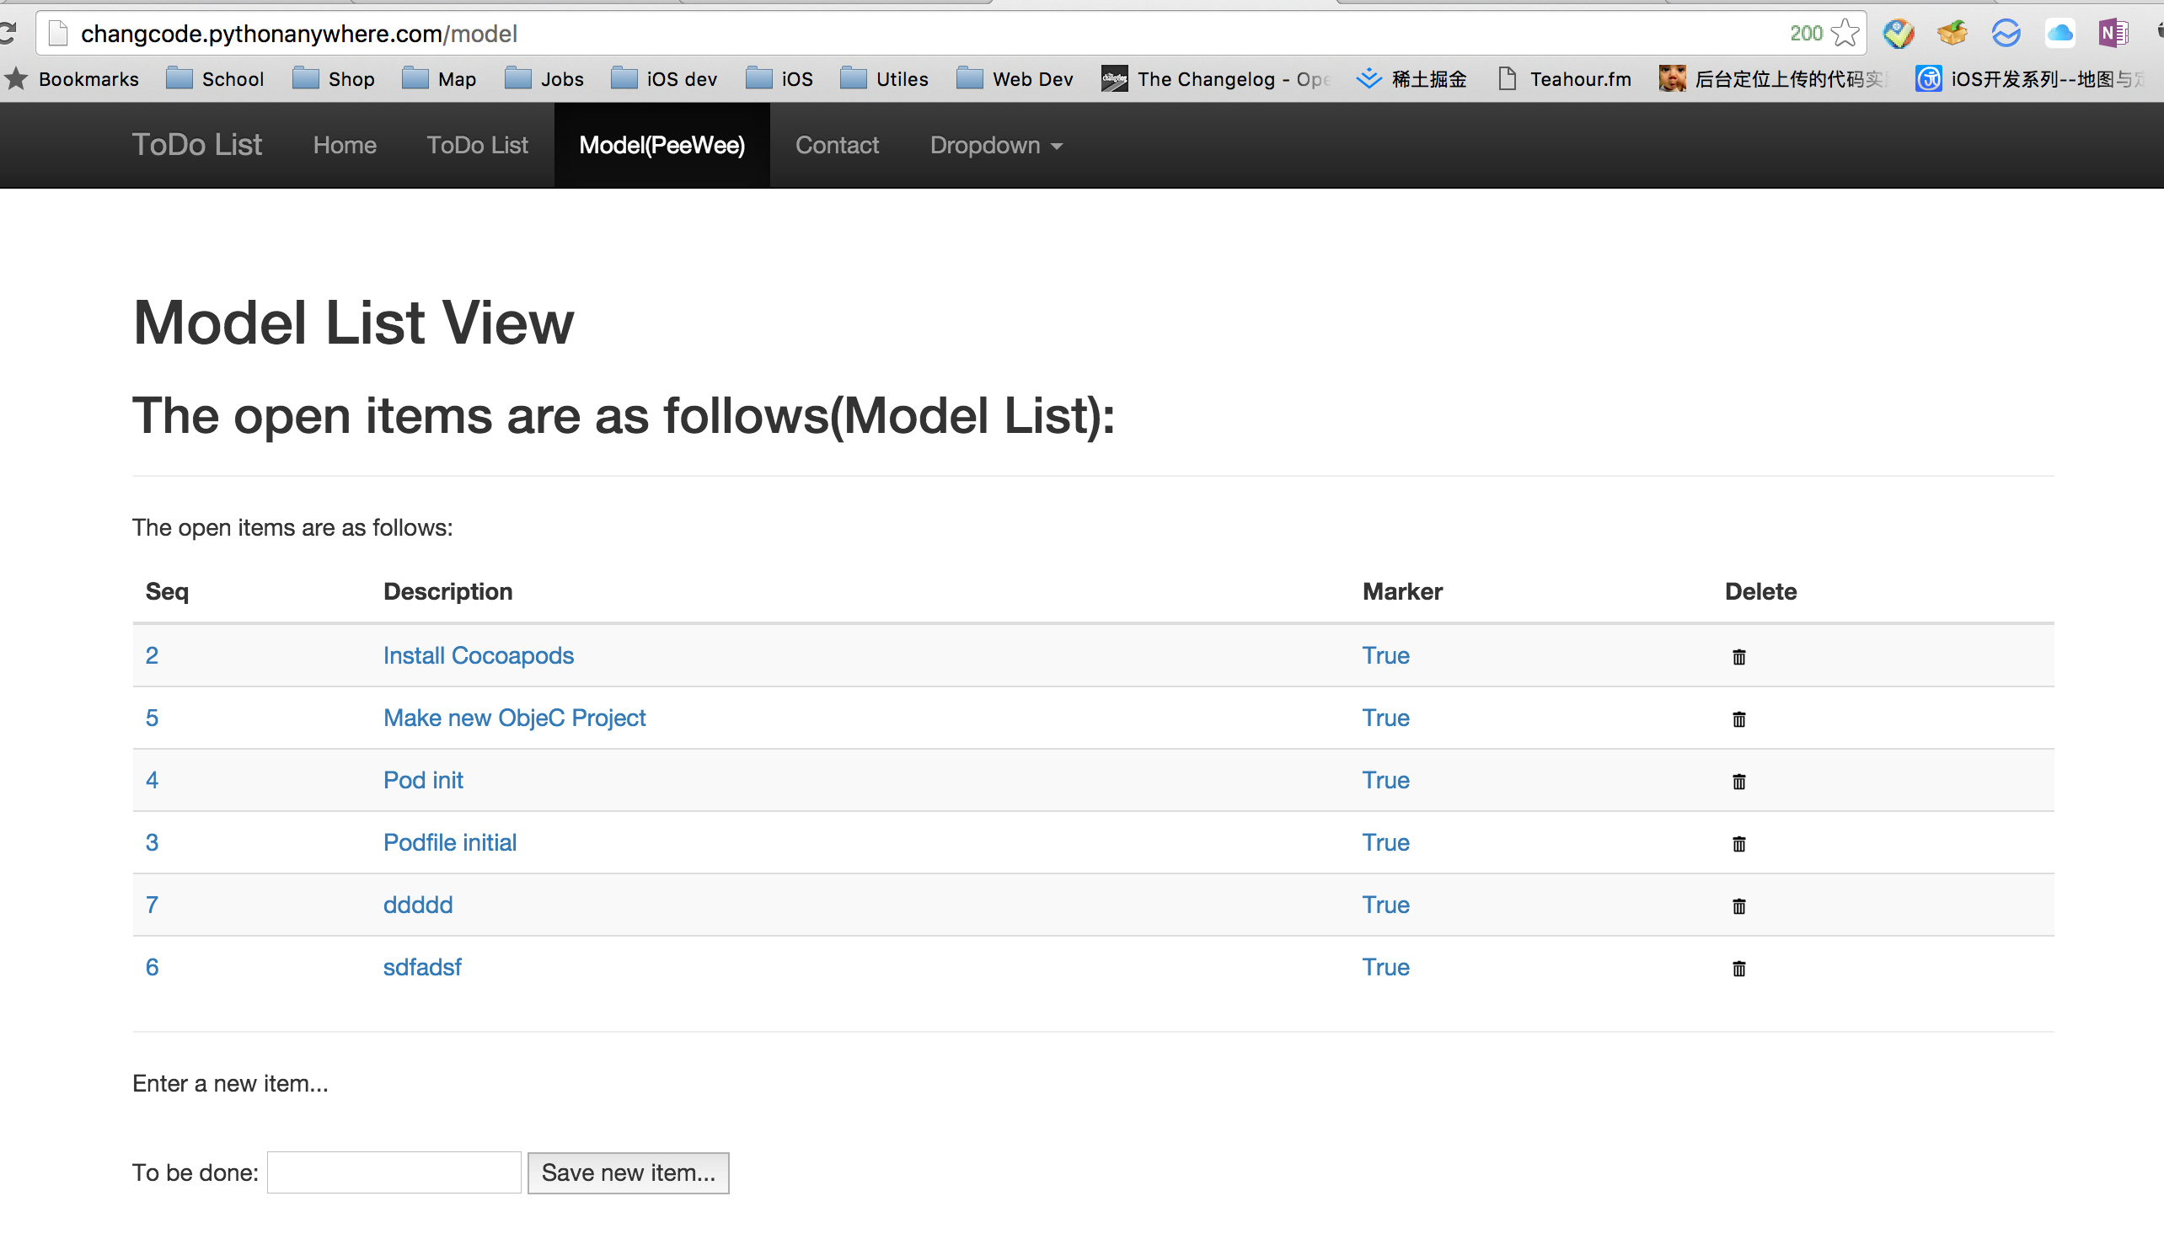

List Model Code:

